**How to attach EFS to Multiple EC2 Instances**

In this project we will explore how we can connect single EFS in to two or more EC2 Instances.

As we know the main disadvantage of EBS is we can’t use EBS as shared storage, since EBS is a DAS (Direct Attached Storage).

EFS is a File Storage which can be used as Shared Storage across multiple Instances.

EC2 only supports Linux as EFS is a NFS (Network File System) which is part of Linux File System.

Architecture:-

Here we create EFS and attach that EFS into EC2 Instances hosted in two different AZ. We create two security group one for EFS and one more for the EC2 Instances.

We will only allow EC2 instances to access EFS.

EFS is a managed storage for EC2.

We can achieve High availability with multi-AZ website hosting with shared file storage.

Steps:-

1. Create Security Groups

First, we will create Security group for Web Server called as “WebSG”.

Navigate to Security Group from EC2 Dashboard. Click on “**Create Security Group”**

Give name and Description, Select the VPC

Add Inbound and outbound Rule.

click on Add Security Group.

WebSG Security Group created.

**Now we will create Security group for EFS**

Steps are Same as above we just need to change inbound and outbound rules according to our requirements.

Here Inbound network traffic type is **NFS**  in rule, in Source we will add the webSG security group as inbound traffic.

Both Security Groups are ready, In **Security Group Dashboard,**  we can see the created Security Groups.

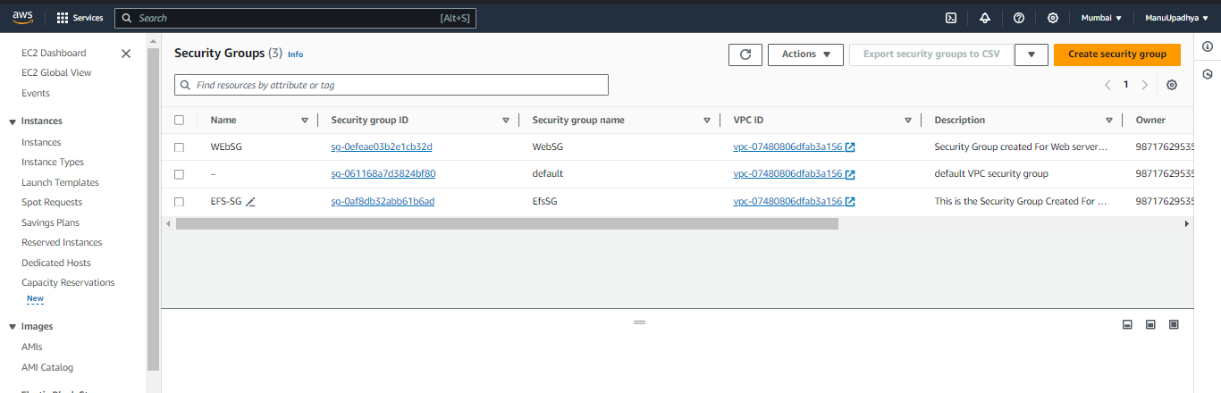

1. Creating EC2 Instances (2 Linux EC2 Instances)

Navigate to Instances in EC2 Dashboard click on Launch Instance

**Creation of first “EFS_Practical_Lab_VM1” Instance**

Give name, select AMI, Select Instance type, Select Key-Pair, in Network settings choose one of the AZ(I selected AP-South-1a). Select Existing Security Group and Select the created Security group. Click on “Launch Instance”

**First EC2 Instance is created.**

We need to create the EC2 instances in different AZ so we must create EC2 instances Separately.

**Creation of Second “EFS_Practical_Lab_VM2” Instance**

Give name, select AMI, Select Instance type, Select Key-Pair, in Network settings choose one of the AZ(I selected AP-South-1b). Select Existing Security Group and Select the created Security group. Click on “Launch Instance”.

Created EC2 Instances (two Linux EC2 Instances)

1. **Create a File System**

Navigate to AWS Management Console and Search for Service EFS.

Navigate to EFS Dashboard then click on “Create File System”.

Give Name for our Fiel Server and Select the VPC then Click on “Customize.”

We Don’t need Automatic backup and encryption so we will disable those in File system settings.

Click next for Network Settings

Remove the default Security Group and add our Created Security Group in Mount Target Section. This is the procedure where we mount our EFS with AZs So that it can be attached to the instances present in those AZs.

Click next for File system Policy, no need to change anything here.

Click next for review and create.

Click on “create” to create EFS.

Created File System in EFS Dashboard.

1. Accessing our EC2 Instances from command prompt.

Use the below command

ssh- i <keyfile> ec2-user@<public-ip>

accessing VM1

Accessing VM2

VM2 Instances side by Side

Install amazon efs utility on these EC2 instances Using below Command.

**Yum install amazon-efs-utils**

Now our all Prerequisites are ready just Mounting of EFS is Remaining.

1. Mounting of EFS.

Navigate to EFS and Select the created EFS, click on view details, click on attach.

We just need to run this command in our both instances.

Before that create EFS folder in both instances.



Now Copy the Command and Paste it

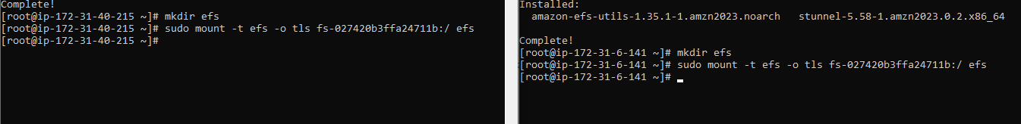

**DONE………………!!!!!!!!!!!!!!!!!!**Now we have shared EFS storage mounted to Both EC2 Linux instances.

1. Verification of attached EFS.

Navigate to the EFS folder in EC2 instances from command prompt.

We can verify the shared storage concept by creating one file in one of the EC2 instance and accessing the file from another instance. By this we can say that we have successfully created shared storage to our EC2 Instances.

**First Linux Instance**

**Second EC2 Instance**

if I just give ls command in second VM I can see the file created in VM1

Now we will create a new file in this instance and access it from first instance.

**First Instance**

**We successfully completed the Practicing EFS Setup and accessing files from shared storage system.**